# **How to Create and Add EBS Volume in AWS Instance (EC2)**

In this topic, we shed light on how you can add or attach an **EBS** (Elastic Block Storage) volume on an AWS instance. An extra EBS volume supplements storage space for your instance. Once attached to the AWS instance, the EBS volume becomes a **block device** that is later formatted and mounted to make it available for use. Once available for use, the block device becomes accessible just like any other volume and thereby supplement storage space for your **AWS instance**. Let’s see how this can be achieved.

#### **Step 1: Confirm the availability zone of your AWS instance**

To start off, log in to your AWS console and confirm the availability zone of your EC2 instance. For this exercise to succeed, The EBS volume, as well as the AWS instance, ought to be in the same availability zone

Our AWS instance in this guide sits at the us-east-2c availability zone. Therefore, we must create an EBS volume in the same region,

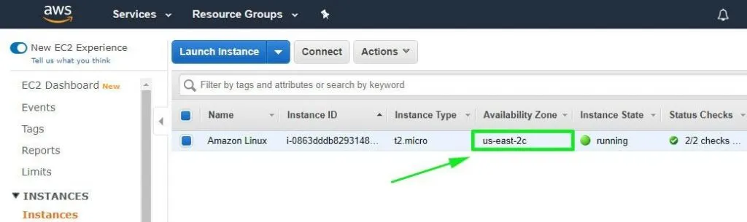

#### **Step 2: Creating an EBS volume**

Before creating a new volume, let’s have a peek at the block devices available in our instance. Run the command :

# lsblk

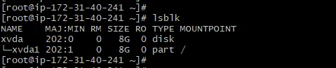

From the above output, we can clearly see that there’s only one block device xvda, with a single partition xvda1. To get more detailed output, run the fdisk -l command:

# fdisk -l



Now let’s add a new volume. On the left section of your AWS dashboard, locate and click on the ‘**Volumes**’ option under the **Elastic Block Store** section as shown.

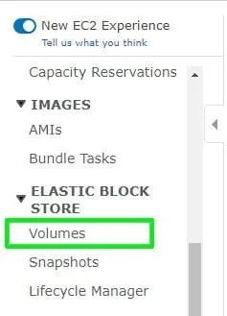

A pre-existing volume will be displayed on the next page. This volume was created during the creation of your AWS EC2 instance.

To add another volume, click on the ‘**Create Volume**’ button

